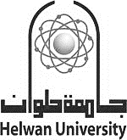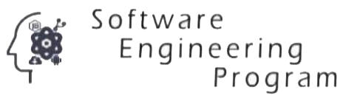

**Helwan University**

**Faculty of Computers and Artificial Intelligence**

**Software Engineering Program**



A graduation project dissertation by:

Mohamed Ali GadAlhak Hassan ( 20201871 )

Assem Mohamed AhmedSamy Mohamed ( 20201836 )

Pola Osama Aziz ( 20201823 )

Ahmed Salah Mohammed ( 20201803 )

Ahmed Waleed Abdullah Ahmed ( 20201815 )

Eslam Sabry Hassan ( 20201849 )

Submitted in partial fulfilment of the requirements for the degree of Bachelor of Science in Computers & Artificial Intelligence, at the Software Engineering Program, the Faculty of Computers & Artificial Intelligence, Helwan University

Supervised by:

**[ Assc. Prof. Mohamed Marie ]**

June 2023